[**Knowledge Drift; The Science of Human Error**](https://knowledgedrift.wordpress.com/)

[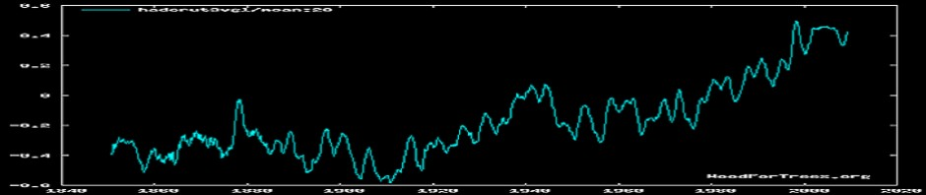](https://knowledgedrift.wordpress.com/)

[Skip to content](https://knowledgedrift.wordpress.com/2011/09/07/co2-is-logarithmic-explained-3/#content)

* [Home](https://knowledgedrift.wordpress.com/)
* [About](https://knowledgedrift.wordpress.com/about/)
* [Climate Humour; Follow the Money](https://knowledgedrift.wordpress.com/climate-humour-page-the-climatologist-and-follow-the-money-series/)
* [Climate Resources; Decide for Yourself](https://knowledgedrift.wordpress.com/climate-resources-decide-for-yourself/)
* [Strange Oddities of History](https://knowledgedrift.wordpress.com/strange-oddities-of-history/)

[← Variability is….what? WHERE?](https://knowledgedrift.wordpress.com/2011/06/02/variability-is-what-where/)

[**CO2 is Logarithmic Explained**](https://knowledgedrift.wordpress.com/2011/09/07/co2-is-logarithmic-explained-3/)

Posted on [September 7, 2011](https://knowledgedrift.wordpress.com/2011/09/07/co2-is-logarithmic-explained-3/)by [davidmhoffer](https://knowledgedrift.wordpress.com/author/davidmhoffer/" \o "View all posts by davidmhoffer)

I keep on saying that

* the “forcing” effects of CO2 are logarithmic while
* the cooling response of the planet rises exponentially.

I’m not the only one saying this, serious heavy weight skeptics like Lindzen are saying the same thing.  So what do these terms really mean?  OK, a bit of background and then onto the pictures.

What is often quoted is that CO2 doubling causes an increase in radiance to earth’s surface of 3.7 watts/meter squared, which in turn raises temperatures about 1 degree Celsius. Why the reference to “doubling”?  Because we’re talking about light and filtering materials.  Consider that you have several pairs of sun glasses, each of which blocks 50% of the light.  If you put two pairs in a row, do they block 100%?  Of course not.  The first pair blocks 50% and the second pair blocks 50% of what is left, which is 25% of the original light.  The third pair would only block 12.5% of the original light.  CO2 suffers from the same law of diminishing returns.  What keeps getting left out of the climate discussion is what happens after the first doubling.  The pre-industrial levels (1900 AD or so) of CO2 are commonly quoted at 278 PPM (parts per million) and the current levels are at about 385 ppm.  If we look at this graph, it becomes pretty clear that we would have to generate a LOT of CO2 to get much more effect than we are already:

[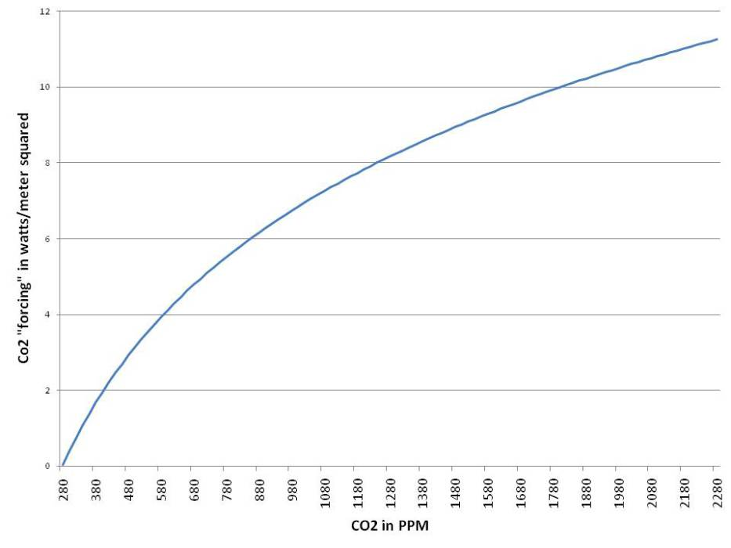](https://knowledgedrift.files.wordpress.com/2010/05/log1-co2.jpg)

It takes more and more CO2 to get just one more watt...

However, to keep the big picture in mind, we have to also remember that as the earth gets warmer, it radiates heat to space.  The ideal black body formula to calculate how much heat is being dissipated to space is P=(5.76×10^-8)(T^4) where P is power in watts per square meter and T is temperature in degrees K or Kelvin.  To convert from the more common degrees C, just add 273.  The “average” temperature (there’s really no such thing) of earth is often quoted as 15 degrees C or 288 K.  This graph shows how much additional heat the earth sends into space as it gets just a few degrees warmer:

[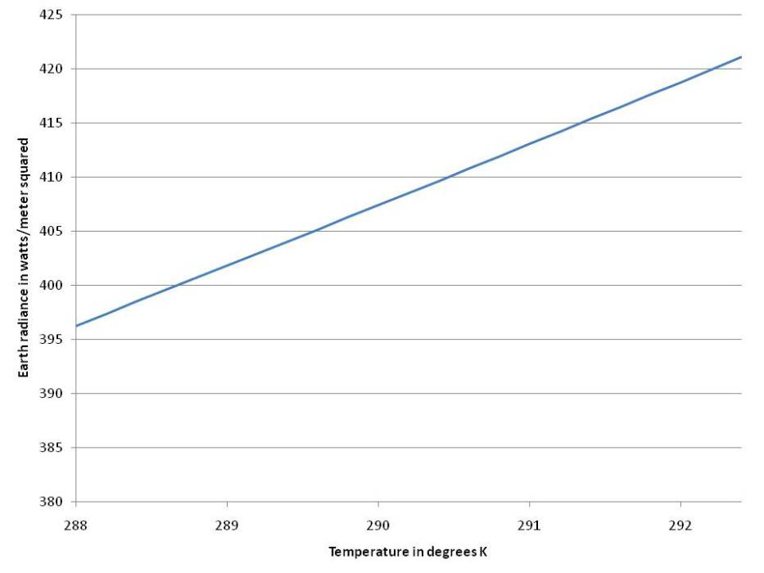](https://knowledgedrift.files.wordpress.com/2010/05/log1-exponential.jpg)

The warmer something is, the more heat it radiates...

So how much does CO2 in theory heat the planet?  If we use the formula above, we see that increasing the earth’s temperature by just 1 degree, from 288 K to 289 K, results in an increase in earth radiance of 5.5 watts per square meter.  This brings up the obvious question.  If earth radiance goes up by 5.5 watts, how could it be caused by only a 3.7 watt rise?  The climatologists have a variety of explanations for this.  In brief, CO2 doesn’t reflect long wave radiance as many people think, it absorbs it.  This heats the CO2 up, which causes it to radiate more heat, but the photons it releases can be emitted in any direction.  Up, down, sideways…  long story short, some escapes to space and some gets sent back to earth, about 3.7 of the 5.5 additional watts.  This issue alone is a long complicated discussion, but rather than argue it, let’s just accept the numbers.  Doubling CO2 levels from the pre-industrial level of 278 PPM causes an increase of 3.7 watts per meter squared, and that results in a temperature increase of 1 degree C.  The various theories then go on to claim that increased temperatures result in increased water vapour, which is itself a greenhouse gas and supposedly adds another 2 degrees C to the warming.  We’ll debunk both of those, but let’s put aside the water vapour for the moment and just focus on the CO2.

In order to put the whole thing in perspective, we have to keep in mind two things.  The first is that in order to get a *second* 3.7 watts (after the first doubling) we would have to double CO2*again*.  So the first doubling would be 278 x 2 = 556 PPM = 3.7 watts.  To get to 7.4 watts, we would have to double again to 1,112 PPM.  As the earth heats up though, the amount of additional power required to raise the temperature just one more degree also goes up.  So, to put everything in perspective, let’s take a look at how much CO2 would be required, without water vapour feedbacks, to directly raise the temperature of the earth from 288 K (15 degrees C) by four degrees.  As you look at the graph, just to put things in perspective, consider the two thin lines at the bottom.  The green line is what CO2 was at pre-industrial, and the red line is where we are at after a century of burning fossil fuels:

[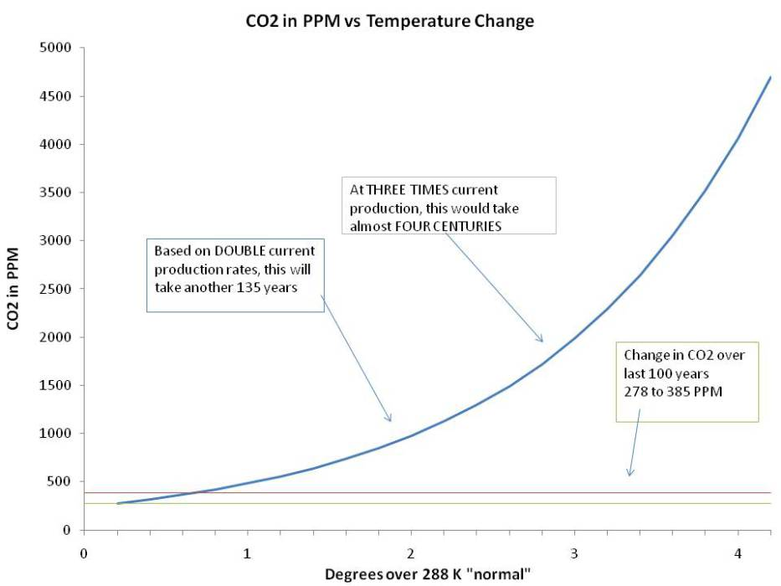](https://knowledgedrift.files.wordpress.com/2010/05/log-1-combined.jpg)

Even at double current rates, it would take over a century to get to +2 degrees....

Several things jump out at us.  The first is just how ridiculous the idea of a “tipping point” really is.  The amount of heat the earth radiates to space just goes up too fast for that,

and the amount of CO2 that is required to maintain any temperature increase at all goes up even faster.  If we were to double the rate at which CO2 in the atmosphere is increasing in comparison to the last 30 years, it would still take well over a century to get to just two degrees of warming from CO2.  If we tripled the rate, it would take almost four centuries to get to three degrees.

But what about positive feedback from water vapour?

There are plenty of things wrong with that theory.  In principle, the amount of water vapour the atmosphere is capable of holding about doubles for every 10 degree rise in temperature.  The theory goes that just a small rise in temperature would increase water vapour which over all has a much larger greenhouse effect than does CO2.  Estimates range anywhere from double to quadruple the additional warming.  The average quoted most often is 1 degree of warming from CO2 and 2 more from water vapour feedback.  Is this reasonable?

If the amount of water vapour in the atmosphere always “maxed out” it might be, but we know that doesn’t happen.  Instead, let’s look at what has*actually* happened.  Since the pre-industrial levels of 278 PPM one hundred or so years ago, CO2 levels have gone up about 38%, not even close to doubling.  In that time, various estimates based on surface station readings around the world have suggested that the earth has warmed up about 0.6 degrees C.   But, we must keep in mind that due to the logarithmic effects of CO2 forcing, and the increased radiance of the earth as it warms, the first 38% has a much larger effect than the*next* 38%.  In fact, if we go back to our graph and look at where we are now, it is easy to see that whatever effects doubling CO2 actually has, almost 70% of that is already happening:

[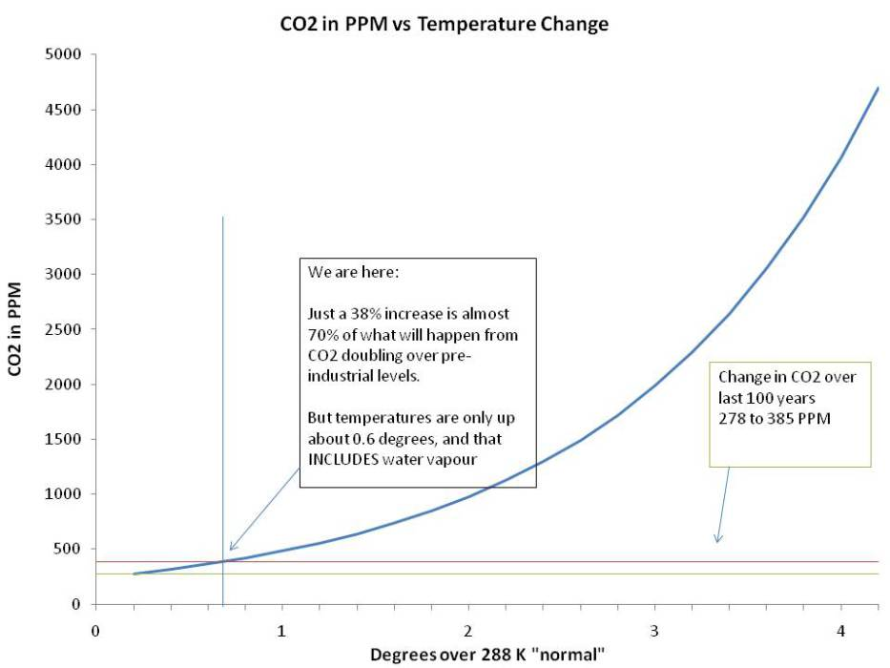](https://knowledgedrift.files.wordpress.com/2010/05/log1-70-percent.jpg)

Current levels are up 38%.... which means almost 70% of the effects of doubling CO2, are already happening.

Even if we accepted the notion that positive feedback from water vapour triples the effects of CO2, we clearly are not seeing that in actual earth temperatures.  If the rough estimates of CO2 doubling = 3.7 watts per square meter = 1 degree plus 2 more from water vapour were correct, we would have seen a temperature increase over the last century of 2.1 degrees, but we’ve only seen 0.6 degrees.  It could be argued that there are natural cooling fluctuations, and the difference between what the earth’s temperature is now, and what it would have been without the extra CO2 would be 2.1 degrees.  That also seems far fetched given that the earth has been in a general warming trend for the last 300 years, and the rate of warming over the last century has been about the same as the previous ones.

The more logical explanation is twofold.  First, the effects of CO2 and positive feedback from water vapour have been far over estimated.  Secondly, even doubling or tripling the amount of CO2 we put into the atmosphere would not appreciably change the warming effects of the CO2 levels we have currently… and then not by much.  This isn’t me making numbers up, it is just a matter of extending the IPCC claims and putting them in perspective to show that the worst is already behind us, and is over estimated in any event.  Even if the estimates of CO2 warming were correct (which they clearly are not) the fact is the bulk of the damage (if any) has already happened, and the amount of fossil fuels we would have to burn to appreciably change that is completely beyond our production capacity.

### 22 Responses to CO2 is Logarithmic Explained

1. https://0.gravatar.com/avatar/3cad54a5f28171601a5943c779033479?s=60&d=identicon&r=G[**Pablo Selzer**](http://www.pcca.org/) *says:*

[November 1, 2011 at 12:10 pm](https://knowledgedrift.wordpress.com/2011/09/07/co2-is-logarithmic-explained-3/#comment-279)

The misleading allegations of the environmentalists of CO2 emissions destroying our planet are unfounded and not backed up by any statistical studies just EMOTION! They are like “chicken little” telling us the sky is falling when it truly is NOT. What Climatologist would endorse their allegations-NONE.

[Reply](https://knowledgedrift.wordpress.com/2011/09/07/co2-is-logarithmic-explained-3/?replytocom=279#respond)

1. https://0.gravatar.com/avatar/3899961a875ee32af82bbfb929d92577?s=60&d=identicon&r=G**Dr. Irvin H. Forbing** *says:*

[February 3, 2013 at 3:02 pm](https://knowledgedrift.wordpress.com/2011/09/07/co2-is-logarithmic-explained-3/#comment-2706)

Are there any peer-reviewed articles that are available to show this logarithmic effect.  
I believe it to be true, but do not have access to such literature.  
Tks,  
Dr. Irvin Forbing [drforbing@hotmail.com](mailto:drforbing@hotmail.com)

[Reply](https://knowledgedrift.wordpress.com/2011/09/07/co2-is-logarithmic-explained-3/?replytocom=2706#respond)

* + https://1.gravatar.com/avatar/dc0bcdb064964102f096aee22521cac8?s=60&d=identicon&r=G[**davidmhoffer**](https://knowledgedrift.wordpress.com/) *says:*

[February 3, 2013 at 3:29 pm](https://knowledgedrift.wordpress.com/2011/09/07/co2-is-logarithmic-explained-3/#comment-2707)

Any first year radiative physics text book would have more detail and references. I believe Robert G Brown (PhD Physics, Duke University) has put his online now for free.

[Reply](https://knowledgedrift.wordpress.com/2011/09/07/co2-is-logarithmic-explained-3/?replytocom=2707#respond)

* + - https://2.gravatar.com/avatar/e083f1fbb8172f14787e8395aa76b76a?s=60&d=identicon&r=G**Aerin** *says:*

[December 17, 2013 at 3:39 am](https://knowledgedrift.wordpress.com/2011/09/07/co2-is-logarithmic-explained-3/#comment-4077)

Can you please provide links to scientific literature showing this? I have tried to find Robert G Brown’s page on logarithmic CO2 that you mention in your comment and it does not seem to exist.

* + - https://1.gravatar.com/avatar/dc0bcdb064964102f096aee22521cac8?s=60&d=identicon&r=G[**davidmhoffer**](https://knowledgedrift.wordpress.com/) *says:*

[December 17, 2013 at 11:23 am](https://knowledgedrift.wordpress.com/2011/09/07/co2-is-logarithmic-explained-3/#comment-4082)

Robert G Brown comments frequently at wattsupwiththat.comas rbgatduke where you can find any number of comments and articles by him and others on the logarithmic nature of CO2. The official literature from the United Nation IPCC also regards CO2 as being logarithmic, as does any text book on spectrography.

* + - https://0.gravatar.com/avatar/3899961a875ee32af82bbfb929d92577?s=60&d=identicon&r=G**Dr. Irvin Forbing** *says:*

[December 17, 2013 at 12:10 pm](https://knowledgedrift.wordpress.com/2011/09/07/co2-is-logarithmic-explained-3/#comment-4083)

David, an “Aerin” has asked the same question that you have. Here’s is a link <https://knowledgedrift.wordpress.com/2011/09/07/co2-is-logarithmic-explained-3/>, but it may not answer your “scientific link” question.

You might want to study the Beer-Lambert Law and you will gleen some good info there.

You might want to try an experiment that Jeffrey Bada of Scripps gave me in his attempt to prove that it was not logarithmic. He had not tried it, but we both did, and CO2 levels could never raise the temps in the experiment more than about 2 deg C. Bada gave up, but still makes the claim.

2 1L bottles half filled with water. Place calibrated thermometers in the air of both, then add one alka seltzer (emits CO2) in one bottle, with the other as control (cork both bottles), and put the temp on a graph every 5 min for 1 hour. for both. Do it with increasing “doses” of alka seltzer (CO2) and it will still not change.

Irv

Date: Tue, 17 Dec 2013 17:23:57 +0000 To:[drforbing@hotmail.com](mailto:drforbing@hotmail.com)

* + - https://1.gravatar.com/avatar/dc0bcdb064964102f096aee22521cac8?s=60&d=identicon&r=G[**davidmhoffer**](https://knowledgedrift.wordpress.com/) *says:*

[December 17, 2013 at 12:30 pm](https://knowledgedrift.wordpress.com/2011/09/07/co2-is-logarithmic-explained-3/#comment-4086)

Thanks Dr. Forbing.  
The experiment you describe however doesn’t take into account the scale of the atmosphere and the ability of CO2 molecules to absorb and re-radiate repeatedly. That’s one of the problems with trying to do a lab experiment that confirms (or denies) CO2’s effects. We just cannot build an apparatus 14 km tall. There was a very good experiment done in great detail by Heinz Hug which you can find here:

[http://web.archive.org/web/20010725082626/http://www.john-daly.com/artifact.htm](http://web.archive.org/web/20010725082626/http:/www.john-daly.com/artifact.htm)

But be sure to read the criticisms of that experiment which you can get from the pdf linked to right under Heinz Hug’s name at the top of the page. Read together with the experiment itself, it is very informative as to the complexity of measuring the effect in the first place. That said, if you follow the IPCC AR reports themselves, they all assume a ln2 function. If I recall correctly, the formula to arrive at sensitivity due to direct effects of Co2 in isolation is dT=5.35ln2((C2-C1)/C1) which appeared in AR3 and has been carried forward to AR4 and Ar5. I’ve forgotten the precise manner in which it was derived, but even arch skeptics like Roy Spencer and Robert Brown and Richard Lindzen accept it as a reasonable approximation as do arch warmists such as Joel Shore and Kevin Trenberth (all PhD physicists). Spectroscopy however is more a core skill set of chemists, and you’ll find that from both sides of the aisle, PhD chemists come up with the same approximation.

1. Pingback: [*Negative Feedbacks: What They Are, and Why They Are Important | The Penn Ave Post*](http://pennavepost.com/conservative/negative-feedbacks-what-they-are-and-why-they-are-important)
2. Pingback: [*Negative Feedbacks: What Are They, And Why Are They Important? | The Global Warming Policy Foundation (GWPF)*](http://www.thegwpf.org/negative-feedbacks-they-important/)
3. Pingback: [*Greenhouse Bullcrap Fundamentals | Greenhouse Bullcrap*](http://greenhousebullcrap.wordpress.com/2012/12/02/greenhouse-bullcrap-fundamentals/)
4. https://0.gravatar.com/avatar/c95ab576546e1b10df5a0a57a6652590?s=60&d=identicon&r=G[**fireofenergy**](http://whatsthebackupplan.wordpress.com/) *says:*

[May 5, 2013 at 9:45 pm](https://knowledgedrift.wordpress.com/2011/09/07/co2-is-logarithmic-explained-3/#comment-3140)

So, as things heat up, we are not to worry because that infrared will not FIRST heat things up on Earth first before eventually escaping the excess co2? I don’t think so (and neither do the icecaps, evidently)!  
Bty, why is it sooooo hard to fathom a clean energy infrastructure based NOT on the past of expensive capacity but created far cheaper via upcoming machine automation? Why, I’ll tell you why… It is because that the truth of excess CO2 is also being used as an excuse to further manipulate the people into excess laws and regulations.

All we need is the industrialists solutions, the technofix and NOT the life sucking politics!

[Reply](https://knowledgedrift.wordpress.com/2011/09/07/co2-is-logarithmic-explained-3/?replytocom=3140#respond)

* + https://0.gravatar.com/avatar/3dbeb9d5286359339c1aa3ffb796d7b5?s=60&d=identicon&r=G**Brian H** *says:*

[May 17, 2015 at 9:59 pm](https://knowledgedrift.wordpress.com/2011/09/07/co2-is-logarithmic-explained-3/#comment-4802)

The energy escaping to space can either increase warming, or escape. Not both. That’s why sat measurements showing monotonic increase of OLR with temps disprove AGW.

[Reply](https://knowledgedrift.wordpress.com/2011/09/07/co2-is-logarithmic-explained-3/?replytocom=4802#respond)

1. https://1.gravatar.com/avatar/dc0bcdb064964102f096aee22521cac8?s=60&d=identicon&r=G[**davidmhoffer**](https://knowledgedrift.wordpress.com/) *says:*

[May 5, 2013 at 10:03 pm](https://knowledgedrift.wordpress.com/2011/09/07/co2-is-logarithmic-explained-3/#comment-3141)

Here’s a link to sea ice data where you can see for yourself that while the northern ice cap is below the 1979 to 2008 mean, the southern ice cap is well above it. Which one is it that agrees with you?

[Reply](https://knowledgedrift.wordpress.com/2011/09/07/co2-is-logarithmic-explained-3/?replytocom=3141#respond)

* + https://1.gravatar.com/avatar/dc0bcdb064964102f096aee22521cac8?s=60&d=identicon&r=G[**davidmhoffer**](https://knowledgedrift.wordpress.com/) *says:*

[May 5, 2013 at 10:57 pm](https://knowledgedrift.wordpress.com/2011/09/07/co2-is-logarithmic-explained-3/#comment-3142)

<http://wattsupwiththat.com/reference-pages/sea-ice-page/>

[Reply](https://knowledgedrift.wordpress.com/2011/09/07/co2-is-logarithmic-explained-3/?replytocom=3142#respond)

1. https://2.gravatar.com/avatar/24197e7699c9f1e1bf7f34fdedf60c76?s=60&d=identicon&r=G[**warrenlb**](http://gravatar.com/warrenlb) *says:*

[May 26, 2014 at 8:12 am](https://knowledgedrift.wordpress.com/2011/09/07/co2-is-logarithmic-explained-3/#comment-4290)

@DavidMHoffer  
What are your Science credentials?

[Reply](https://knowledgedrift.wordpress.com/2011/09/07/co2-is-logarithmic-explained-3/?replytocom=4290#respond)

* + https://1.gravatar.com/avatar/dc0bcdb064964102f096aee22521cac8?s=60&d=identicon&r=G[**davidmhoffer**](https://knowledgedrift.wordpress.com/) *says:*

[May 26, 2014 at 8:25 am](https://knowledgedrift.wordpress.com/2011/09/07/co2-is-logarithmic-explained-3/#comment-4291)

If you wish to discuss the science by all means. If you wish to have a credential war, I’m not interested. The issues I raise in this post can be confirmed in any physics text book that covers the topic, and indeed they are confirmed in the IPCC literature itself (though very clever wording tends to obscure and distract attention from the core science). If there is an error in my math or my physics, by all means point it out.

[Reply](https://knowledgedrift.wordpress.com/2011/09/07/co2-is-logarithmic-explained-3/?replytocom=4291#respond)

* + - https://2.gravatar.com/avatar/277ee39d362070ab972638674c3eca4e?s=60&d=identicon&r=G**DerekB** *says:*

[May 24, 2015 at 8:10 pm](https://knowledgedrift.wordpress.com/2011/09/07/co2-is-logarithmic-explained-3/#comment-4807)

No, credentials matter. It’s not enough to possess the tools, you have to know how to use them.  
Your calculation of the additional radiation from the Earth’s surface at a raised temperature overlooks that 90% of that radiation gets bounced back down by the troposphere. Crudely, you’d need ten times the increased radiation out to balance the increased greenhouse forcing. But that’s an overestimate for yet subtler reasons.

* + - https://1.gravatar.com/avatar/dc0bcdb064964102f096aee22521cac8?s=60&d=identicon&r=G[**davidmhoffer**](https://knowledgedrift.wordpress.com/) *says:*

[May 24, 2015 at 8:41 pm](https://knowledgedrift.wordpress.com/2011/09/07/co2-is-logarithmic-explained-3/#comment-4808)

Uh… no.  
If you needed 10 times as much out to “balance” the increased GHG forcing, by definition, the system would NOT be balanced.  
If you familiarize yourself with the application of Stefan-Boltzmann equations, one of the things that you will discover is that the amount of energy out before CO2 doubles is precisely the same as energy out after CO2 doubles with the exception of the transient period during which the system is realigning itself with warmer surface temps and cooler upper atmosphere temps. But the transient phase is, well, transient. Temporary in other words.

1. https://0.gravatar.com/avatar/05b13fd206f21d12f7d1ea4ebf92fd71?s=60&d=identicon&r=G[**TheTracker (@IdiotTracker)**](http://twitter.com/IdiotTracker) *says:*

[October 5, 2014 at 2:02 pm](https://knowledgedrift.wordpress.com/2011/09/07/co2-is-logarithmic-explained-3/#comment-4625)

How is asking for your credentials an invitation “credential war”?

Your defensiveness on the topic certainly speaks volumes!

While one can certainly point out the many, many errors in what you humorously describe as “your math” and “your physics,” is that really a worthwhile exercise when dealing with somebody with no scientific chops whatsoever?

[Reply](https://knowledgedrift.wordpress.com/2011/09/07/co2-is-logarithmic-explained-3/?replytocom=4625#respond)

* + https://1.gravatar.com/avatar/dc0bcdb064964102f096aee22521cac8?s=60&d=identicon&r=G[**davidmhoffer**](https://knowledgedrift.wordpress.com/) *says:*

[October 5, 2014 at 4:51 pm](https://knowledgedrift.wordpress.com/2011/09/07/co2-is-logarithmic-explained-3/#comment-4626)

The math comes straight out of formulas published in the United Nations Intergovernmental Panel on Climate Change, AR1 through AR5. The formula was plugged into an Excel spreadsheet using the built in natural log function and graphed for the range of CO2 concentrations shown. If you think the physics is wrong, by all means, go tell the IPCC, I’m sure they will be glad to hear from you. If you think the math is wrong, go tell the IPCC, they will be glad to hear from you. IF you can demonstrate that the math or physics is wrong, by all means, provide the documentation right here right now with a full explanation as to why. You won’t because you can’t, the reason you whine about credentials is that you have none of your own, you have no working knowledge of the math or physics to challenge me with, so instead you demand my credentials. That’s all you got? Seriously? The fact that CO2 is logarithmic is strewn throughout the IPCC reports, it is strewn throughout every physics paper and climatology paper on sensitivity that I’ve ever read. It is in every radiative physics text book written in the last 100 years.

If you wanted to point out that I have left out feedbacks from the direct effects of CO2 in my article, you would be correct. But you don’t even have the working knowledge of the subject to notice that. Talk about a lack of scientific chops, LOL.

[Reply](https://knowledgedrift.wordpress.com/2011/09/07/co2-is-logarithmic-explained-3/?replytocom=4626#respond)

1. https://0.gravatar.com/avatar/3dbeb9d5286359339c1aa3ffb796d7b5?s=60&d=identicon&r=G**Brian H** *says:*

[May 17, 2015 at 9:53 pm](https://knowledgedrift.wordpress.com/2011/09/07/co2-is-logarithmic-explained-3/#comment-4801)

Note the new paper by Bill Gray,<http://tropical.atmos.colostate.edu/Includes/Documents/Publications/gray2012.pdf>. The upper troposphere is dried, not moistened, by cumulus storm clouds. There is no positive feedback, and ECS is consequently about 0.3K, +/- 0.1K.

Your graphs will be far more graphic with those numbers plugged in!

[Reply](https://knowledgedrift.wordpress.com/2011/09/07/co2-is-logarithmic-explained-3/?replytocom=4801#respond)

1. https://0.gravatar.com/avatar/f785cebfcdd5329166ccaf6b44275a1e?s=60&d=identicon&r=G**Alan McIntire** *says:*

[November 19, 2015 at 11:38 am](https://knowledgedrift.wordpress.com/2011/09/07/co2-is-logarithmic-explained-3/#comment-4923)

Check out “Voigt Profile” on an online search. At low concentrations of a gas, wattage is proportional to N, at medium concentrations it’s proportional to SQRT(ln N), and at high concentrations, it’s proportional to SQRT(N)

[Reply](https://knowledgedrift.wordpress.com/2011/09/07/co2-is-logarithmic-explained-3/?replytocom=4923#respond)

### Leave a Reply